55341 Lab 11: Creating and managing deployment images

Lab: Using MDT to deploy Windows Server 2022

**Scenario**

Adatum Corporation is a global engineering and manufacturing company with a head office based in London, UK. An IT office and datacenter are located in London to support the London location and other locations. Adatum has recently deployed a Windows Server 2022 server and client infrastructure. As the datacenter has grown, it has become apparent that there can be significant time savings if server deployment is automated by using customized images rather than manually installing each server. You decided to implement an automation process for deploying servers using MDT.

Exercise 1: Configuring MDT

**Scenario**

To make more rapid deployments of custom images in the Adatum Corporation datacenters, you have been given the task of testing the MDT. Your first step for the Windows Server 2022 deployment is to configure MDT before you can begin testing.

The main task for this exercise is as follows:

1. Configure the deployment share.

Task 1: Configure the deployment share

1. Switch to [**LON-SVR1**](urn:gd:lg:a:select-vm), send the [**CTRL+ALT+DEL**](urn:gd:lg:a:send-vm-key-combo) command and login as [**Adatum\AdatumAdmin**](urn:gd:lg:a:send-vm-keys) with the password [**Pa55w.rd**](urn:gd:lg:a:send-vm-keys).
2. Once logged in, click the **Start** button, in the menu, scroll down the list of apps, expand **Microsoft Deployment Toolkit**, and then click the **Deployment Workbench** item.

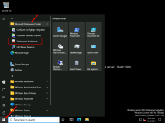

1. In the **Deployment Workbench** console, click the **Deployment Shares** node.

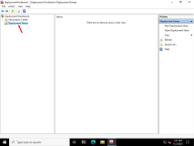

1. Right-click the **Deployment Shares** node, and then click **New Deployment Share**.

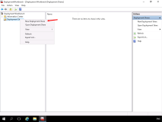

1. In the **New Deployment Share Wizard**, on the **Path** page, in the **Deployment share path** field, ensure that **C:\DeploymentShare** is listed in the **Deployment share path** text box. If it is not, enter it into the text box, and then click **Next**.

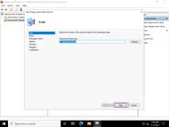

1. On the **Share** page, notice the name of the deployment share (it is a hidden share), and then click **Next**.

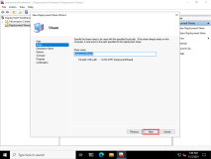

1. On the **Descriptive Name** page, note that this name, and not the path, will appear in the Deployment Workbench, and then click **Next**.

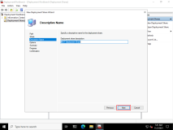

1. Review the **Options** page, ensure that the **Ask for a product key** and **Ask to set the local Administrator password** check boxes are cleared, and then click **Next**.

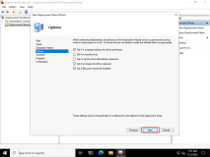

1. On the **Summary** page, click **Next**.

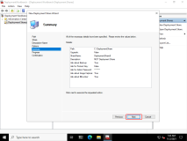

1. On the **Confirmation** page, click **Finish**.

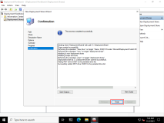

**Results** : After completing this exercise, you should have configured MDT and the MDT Deployment Share.

Exercise 2: Creating and deploying an image

**Scenario**

LON-SVR6 is a new server without an operating system. You decide to test MDT 2013 Update 2 by creating a reference image of Windows Server 2022, and then deploy the image as a deployment to LON-SVR6, while also installing the Excel viewer application.

The main tasks for this exercise are as follows:

1. Add a reference image (Windows Server 2022).
2. Add an application to the image.
3. Create the deployment task sequence.
4. Deploy the Image to LON-SVR6.
5. Prepare for the next module.

Task 1: Add a reference image (Windows Server 2022)

1. Ensure you are on the [**LON-SVR1**](urn:gd:lg:a:select-vm) VM, then on the home tab in the portal, click on the media icon (the icon that looks like a DVD) and select **WinServer2022_Eval.iso** to insert the DVD into the virtual machine.

**Note**: It can take a moment for the ISO image to be succesfully inserted into the VM.

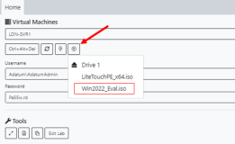

1. On the taskbar, click **File Explorer**.

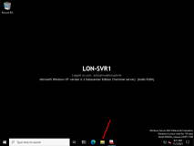

1. In **File Explorer**, in the console tree, make a note of the drive letter the mounted DVD is using.

**Note**: Your drive letter may differ from the one shown in the screenshot.

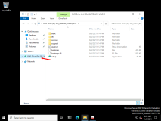

1. Return to the **Deployment Workbench**, and expand **Deployment Shares**, and then expand **MDT Deployment Share (C:\DeploymentShare)**.

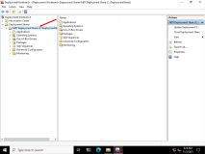

1. Under the **MDT Deployment Share (C:\DeploymentShare)** node, right-click the **Operating Systems** folder, and then click **Import Operating System**.

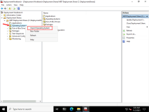

1. In the **Import Operating System Wizard**, on the **OS Type** page, select the **Full set of source files** option, and then click **Next**.

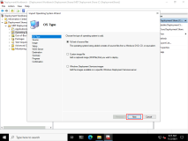

1. On the **Source** page, in the **Source directory** text box, type the drive letter of the DVD you noted in step 5 above, for example, **D:\**, and then click **Next**.

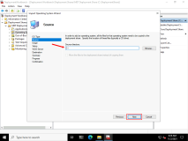

1. On the **Destination** page, in the **Destination directory name** text box, type [**WindowsServer2022x64**](urn:gd:lg:a:send-vm-keys), and then click **Next**.

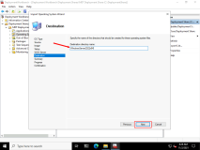

1. On the **Summary** page, click **Next**.

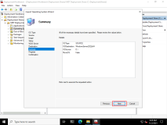

1. The operating system import will take about 5 minutes. On the **Confirmation** page, click **Finish**.

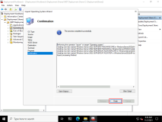

Task 2: Add an application to the image

1. Return to the **Deployment Workbench** console.

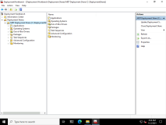

1. Right-click **Applications**, and then select **New Application**.

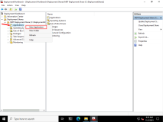

1. In the **New Application Wizard**, on the **Application Type** page, ensure the **Application with source files** option is selected, and then click **Next**.

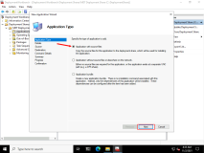

1. On the **Details** page, in the **Publisher** text box, type [**Microsoft**](urn:gd:lg:a:send-vm-keys) and in the **Application Name** text box, type [**ExcelViewer**](urn:gd:lg:a:send-vm-keys), and then click **Next**.

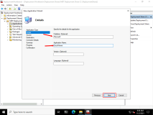

1. On the **Source** page, in the **Source directory** text box, type [**D:\Labfiles\Mod11**](urn:gd:lg:a:send-vm-keys), and then click **Next**.

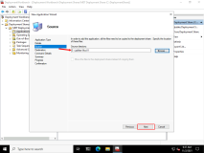

1. On the **Destination** page, in the **Specify the name of the directory that should be created** text box, type [**ExcelViewer**](urn:gd:lg:a:send-vm-keys), and then click **Next**.

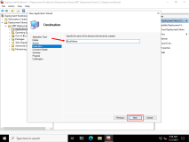

1. On the **Command Details** page, in the **Command line** text box, type [**ExcelViewer.exe /quiet /norestart**](urn:gd:lg:a:send-vm-keys) and then click **Next**.

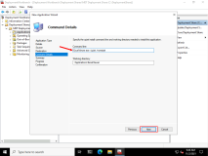

1. On the **Summary** page, click **Next**.

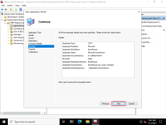

1. On the **Confirmation** page, click **Finish**.

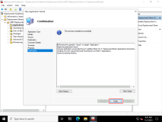

Task 3: Create the deployment task sequence

1. Click **Task Sequences**.

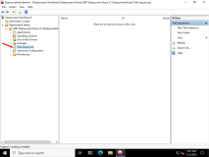

1. Right-click **Task Sequences**, and then select **New Task Sequence**.

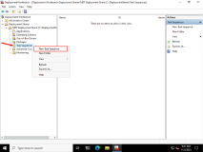

1. The **New Task Sequence Wizard** opens to the **General Settings** page. In the **General Settings** page, in the **Task sequence ID** text box, type [**11-01**](urn:gd:lg:a:send-vm-keys), and in the **Task sequence name** text box, type [**Lab 11-01**](urn:gd:lg:a:send-vm-keys), and in the **Task sequence comments**, type [**Windows Server 2022 Deployment to LON-SVR6 task sequence for Module 11 lab**](urn:gd:lg:a:send-vm-keys), and then click **Next**.

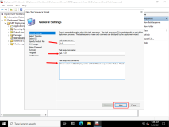

1. On the **Select Template** page, in the drop-down list, select the **Standard Server Task Sequence**, and then click **Next**.

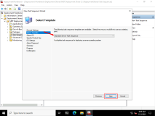

1. On the **Select OS** page, in the **Operating Systems** list, click **Windows Server 2022 SERVERDATACENTER in WindowsServer 2022x64 install.wim**, and then click **Next**.

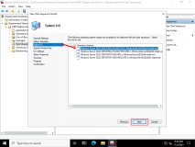

1. On the **Specify a Product Key** page, ensure the **Do not specify a product key at this time** option is selected, and then click **Next**.

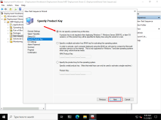

1. On the **OS Settings** page, in the **Full Name** text box, type [**Administrator**](urn:gd:lg:a:send-vm-keys), and in the **Organization** text box, type [**Adatum Corporation**](urn:gd:lg:a:send-vm-keys), and then click **Next**.

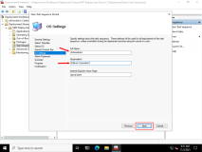

1. On the **Admin Password** page, select the **Use the specified local Administrator password** ption, and, in the **Administrator Password** and **Please confirm Administrator Password** text boxes, type [**Pa55w.rd**](urn:gd:lg:a:send-vm-keys), and then click **Next**.

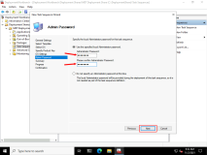

1. On the **Summary** page, review the selected options, and then click **Next**.

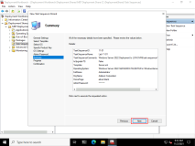

1. On the **Confirmation** page, click **Finish**.

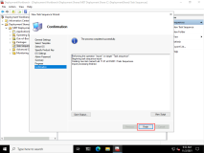

1. In the details pane of the **Task Sequences** node in **the Deployment Workbench**, double-click the **Lab11-01** task sequence.

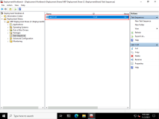

1. In the **Lab 11-01 Properties** window, select the **Task Sequence** tab.

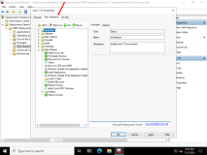

1. In the console tree, expand the **State Restore** node, and below it, select the **Install Applications** node.

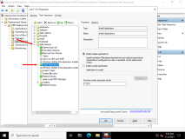

1. In the details pane of **Install Applications**, select the **Install a single application** option, and then click **Browse**.

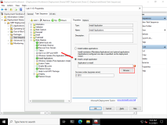

1. In the **Select an item** window, select the **Microsoft ExcelViewer** item, and then click **OK**.

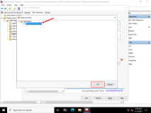

1. To close the **Lab 11-01 Properties** window, click **OK**.

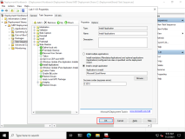

1. In the console tree of the **Deployment Workbench**, select and then right-click the **MDT Deployment Share (C:\DeploymentShare)** node, and then select **Update Deployment Share**.

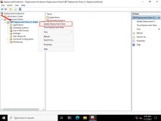

1. The **Update Deployment Share Wizard** will start. On the **Options** page, click **Next**.

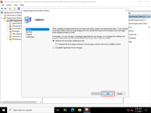

1. On the **Summary** page, click **Next**.

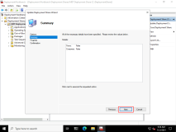

1. The boot image will be made, and the deployment will be completed. This could take several minutes.

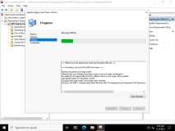

1. On the **Confirmation** page, click **Finish**.

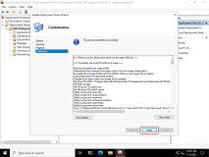

1. Right click the **MDT Deployment Share (C:\DeploymentShare)** node, select **Properties**.

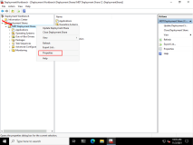

1. Select the **Monitoring** tab.

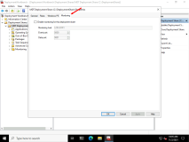

1. Check the box that says **Enable Monitoring for this Deployment Share**, and then click **OK**.

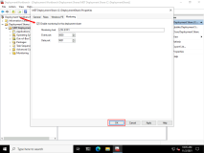

Task 4: Deploy the image to LON-SVR6

1. Switch to the [**LON-SVR6**](urn:gd:lg:a:select-vm) virtual machine.
2. The **LiteTouchPE_x64.iso**, has already been inserted and the VM should have booted from it.
3. The **Microsoft Deployment Toolkit** splash screen will appear as it loads the deployment task.

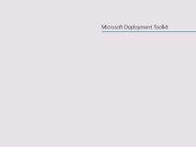

1. The **Microsoft Deployment Toolkit** wizard will start. On the **Welcome** page, select the **Run the Deployment Wizard to install a new Operating system** item.

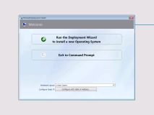

1. On the **User Credentials** page, in the **User Name** text box, type [**adatumadmin**](urn:gd:lg:a:send-vm-keys), in the **Password** text box, type [**Pa55w.rd**](urn:gd:lg:a:send-vm-keys), and in the **Domain** text box, type [**Adatum.com**](urn:gd:lg:a:send-vm-keys), and then click **OK**.

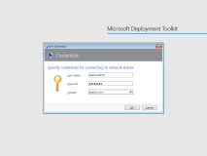

1. On the **Task Sequence** page, select the **Lab 11-01** task sequence item, and then click **Next**.

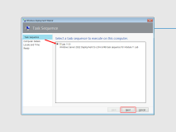

1. On the **Computer Details** page, in the **Computer name** text box, type [**LON-SVR6**](urn:gd:lg:a:send-vm-keys), and then click the **Join a domain** option.

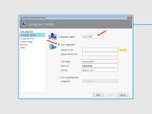

1. In the **Domain to join** text box, type [**Adatum.com**](urn:gd:lg:a:send-vm-keys). Leave the **Organizational Unit** secion blank. Click **Next**.

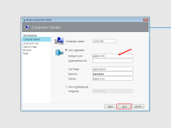

1. On the **Locale and Time** page, click **Next**.

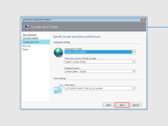

1. On the **BitLocker** page, ensure the **Do not enable BitLocker for this computer** option is selected, and then click **Next**.

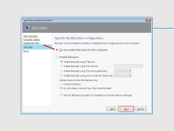

1. On the **Ready** page, click **Begin**.

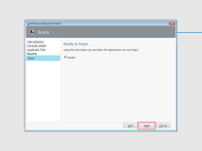

1. An **Installation Progress** window appears that allows you to monitor the progress of the deployment.

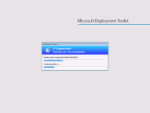

1. Switch to [**LON-SVR1**](urn:gd:lg:a:select-vm). In the **Deployment Workbench**, expand the **MDT Deployment Share (C:\DeploymentShare)** node, and then select the **Monitoring** node. Right-click it, and then select **Refresh**. You will see updating information for the **Lab 11-01** task sequence in the details pane.

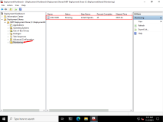

1. After a few moments, [**LON-SVR6**](urn:gd:lg:a:select-vm) will restart and finalize the settings.

**Note:** This can take up to 15 minutes.

1. The Windows Server 2022 desktop will appear. Wait until the **Installation Progress** window appears, and you should see the installation take place within this window.

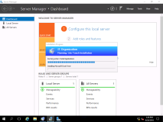

1. You will see the **Installing Microsoft Excel Viewer** progress bar appear under the **Running Action: Install Applications** progress The **Installation Progress** window will then close after a few minutes.
2. A **Deployment Summary** page appears, stating **Operating system deployment completed successfully**. Click **Finish**.

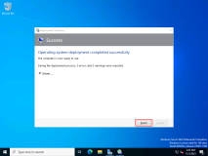

1. In the **Server Manager** console tree, select **Local server**. In the details pane of local server, examine the **Computer Name** and **Domain** status. If the **Domain** status shows as **Unknown**, click the **Refresh** icon. It should be named **LON-SVR6**and be in the **Adatum.com** domain.

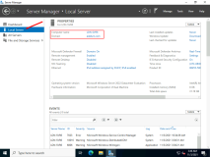

1. Click the **Start menu** icon and in the returned list, observe the **Microsoft Office Excel Viewer** app is listed.

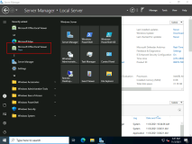

**Results**: After completing this exercise, you should have used MDT to deploy Windows Server 2022 to **LON-SVR6**, and then you should have tested the deployment of an application.

**Congratulations!** You have now completed this lab. To continue to the next lab click End Lab in the Tools Menu . If you wish to contiue with this lab at a later date ensure you save the lab environment rather than ending it.